# Question

Given an array of integers arr, return *true if and only if it is a valid mountain array*.

Recall that arr is a mountain array if and only if:

* arr.length >= 3
* There exists some i with 0 < i < arr.length - 1 such that:
  + arr[0] < arr[1] < ... < arr[i - 1] < arr[i]
  + arr[i] > arr[i + 1] > ... > arr[arr.length - 1]

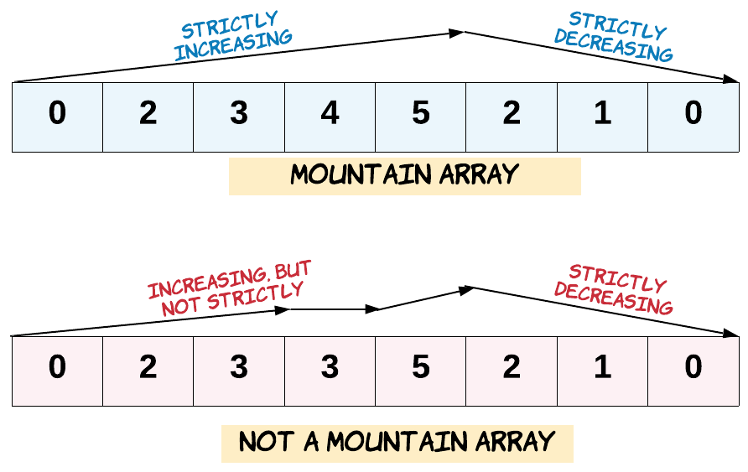

**Example 1:**

**Input:** arr = [2,1]

**Output:** false

**Example 2:**

**Input:** arr = [3,5,5]

**Output:** false

**Example 3:**

**Input:** arr = [0,3,2,1]

**Output:** true

**Constraints:**

* 1 <= arr.length <= 104
* 0 <= arr[i] <= 104

Hide Hint #1

It's very easy to keep track of a monotonically increasing or decreasing ordering of elements. You just need to be able to determine the start of the valley in the mountain and from that point onwards, it should be a valley i.e. no mini-hills after that. Use this information in regards to the values in the array and you will be able to come up with a straightforward solution.

# Solution

#### **Approach 1: One Pass**

**Intuition**

If we walk along the mountain from left to right, we have to move strictly up, then strictly down.

**Algorithm**

Let's walk up from left to right until we can't: that has to be the peak. We should ensure the peak is not the first or last element. Then, we walk down. If we reach the end, the array is valid, otherwise its not.

|  |
| --- |
| class Solution {  public boolean validMountainArray(int[] A) {  int N = A.length;  int i = 0;  // walk up  while (i+1 < N && A[i] < A[i+1])  i++;  // peak can't be first or last  if (i == 0 || i == N-1)  return false;  // walk down  while (i+1 < N && A[i] > A[i+1])  i++;  return i == N-1;  }  } |

**Complexity Analysis**

* Time Complexity: O(N)*O*(*N*), where N*N* is the length of A.
* Space Complexity: O(1)*O*(1).